**Arsenii Dobrovolskyi**

**MIT-21**

**Lab 1 report**

Task 1 (Random number generator using System.Random)

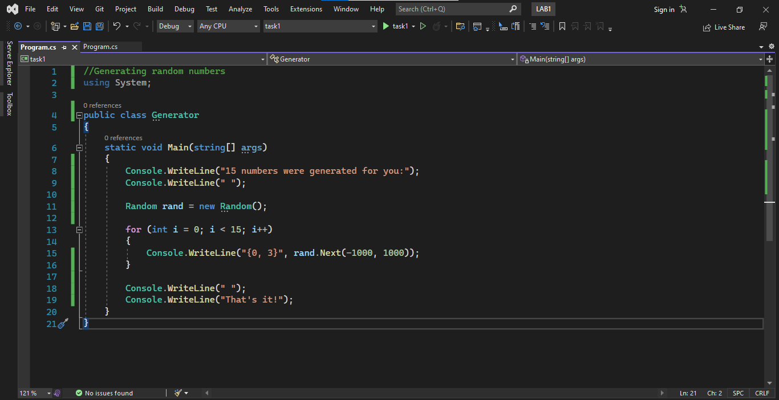

Output:

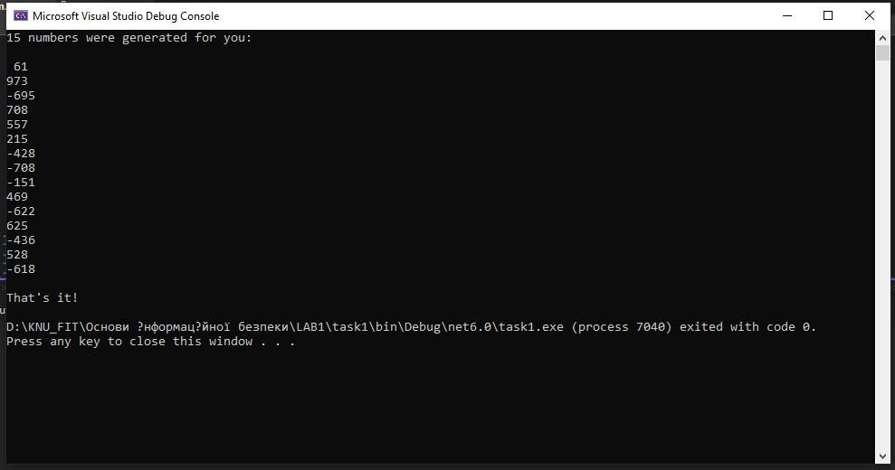

Task 2 (Random number generator using RNGCryptoServiceProvider)

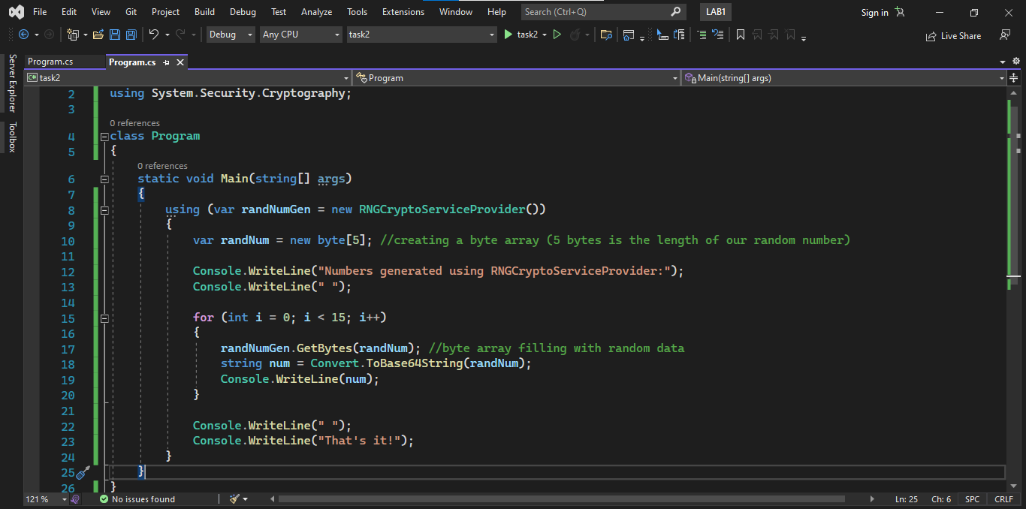

Output:

